How do muscles get the energy they need for athletic activity?

To play a sport, run a race, or any other type of athletic activity, your muscles must contract. Muscles need energy to contract.

A single muscle contraction requires many repeats of the coupled reactions shown in this figure.  1a. Circle the chemical reaction that provides the energy for muscles to contract. | 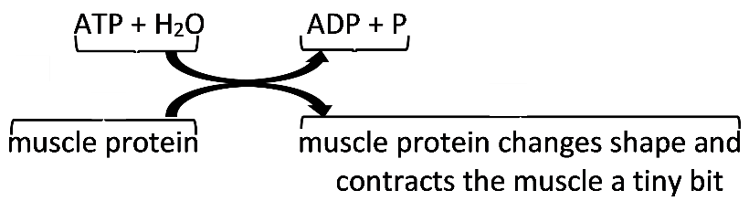  The pair of curved arrows represents coupled reactions; the top reaction provides the energy needed for the bottom reaction.
1b. How often does this chemical reaction occur when a person throws a ball?
once ___ twice ___ a few times ___ many times ___

A typical muscle cell at rest has only enough ATP for 1 or 2 seconds of contraction. For physical activity that lasts longer than 1 or 2 seconds, muscle cells need to make additional ATP. One way that a muscle cell can make more ATP is cellular respiration.

2. This figure summarizes the process of cellular respiration. Write one or two sentences that describe the process of cellular respiration. | 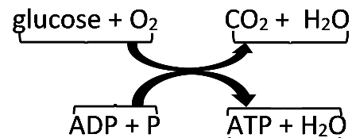

Inside each muscle cell there is a constant cycle of synthesis and breakdown of ATP.  3a. Add to the top of this diagram to show how ATP is made.  3b. Add to the bottom of this diagram to show how ATP is used to provide the energy for muscle contraction. | 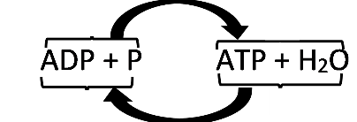

In addition to aerobic cellular respiration, the other main process that makes ATP in muscle cells is anaerobic fermentation.
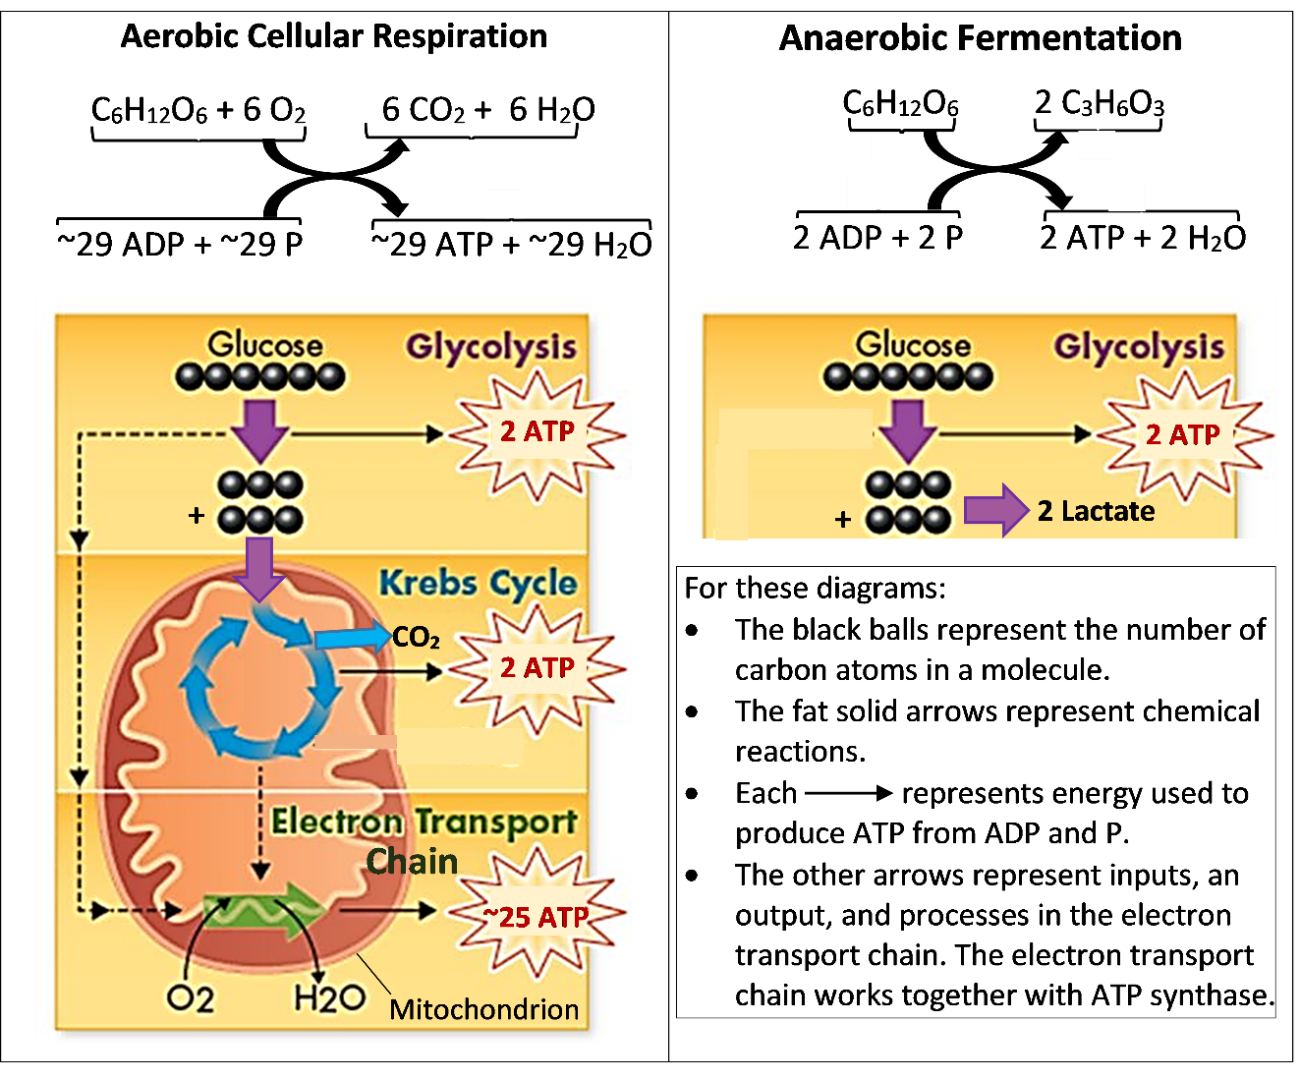

4a. Which molecule is an input for aerobic respiration, but not for anaerobic fermentation?

4b. What does anaerobic mean?

5. A cell produces much more ATP per molecule of glucose when O₂ is available. Explain why.

Most of the ATP for muscle contraction is produced by aerobic cellular respiration or anaerobic
fermentation. However, muscle cells can produce a brief burst of ATP by using energy from the hydrolysis of creatine phosphate (also called phosphocreatine).

The primary source of ATP for muscle contraction varies, depending on the intensity and duration of physical activity. To learn more, read the following information and answer questions 6-8.

- Hydrolysis of creatine phosphate can produce ATP more rapidly than anaerobic fermentation or aerobic cellular respiration. Muscle cells typically have enough creatine phosphate to supply ATP for about 10 seconds of intense activity.

- Anaerobic fermentation is faster than aerobic cellular respiration and does not require O₂, so anaerobic fermentation can provide a lot of ATP for brief intense athletic events. However, anaerobic fermentation can only be a major source of ATP for about a minute. During anaerobic fermentation, acidity and muscle fatigue increase.

- Aerobic cellular respiration is the slowest of these ATP sources, but aerobic cellular respiration produces more ATP per glucose molecule than anaerobic fermentation and aerobic cellular respiration can continue for hours.

The relative importance of these three processes varies for different sports. For example, consider these different types of race.
Running Distance | Running Time (world record; US high school record) | Speed
100 m | 9.6 seconds; 10.0 seconds | 10.4; 10.0 m/sec.
400 m | 43.2 seconds; 44.7 seconds | 9.3; 8.9 m/sec.
Marathon (42.2 km) | 2 hours 3 min. 23 sec.; 2 hours 23 min. 47 sec. | 5.7; 4.9 m/sec.

6a. Which process do you think produces most of the ATP in muscle cells during a marathon?
hydrolysis of creatine phosphate ___ anaerobic fermentation ___
aerobic cellular respiration ___

6b. Explain your reasoning.

7a. During a 100 m sprint, hydrolysis of creatine phosphate is the most important contributor to ATP production in muscle cells. Explain why.

7b. Hydrolysis of creatine phosphate is less important for longer races. Explain why.

8a. Anaerobic fermentation supplies much of the ATP that muscle cells need for a 400 m race. For this race, what is an advantage of anaerobic fermentation over aerobic cellular respiration?

8b. What is a disadvantage of anaerobic fermentation for longer races?

How Oxygen and Glucose Get to the Muscles

This chart shows how the respiratory, digestive, and circulatory systems cooperate to supply muscles with oxygen and glucose.
9a. Draw a rectangle around the part of the chart that shows aerobic cellular respiration.  9b. If not enough oxygen is available, the muscles use anaerobic fermentation of glucose to produce ATP. Draw an oval around the part of the chart that shows anaerobic fermentation. | 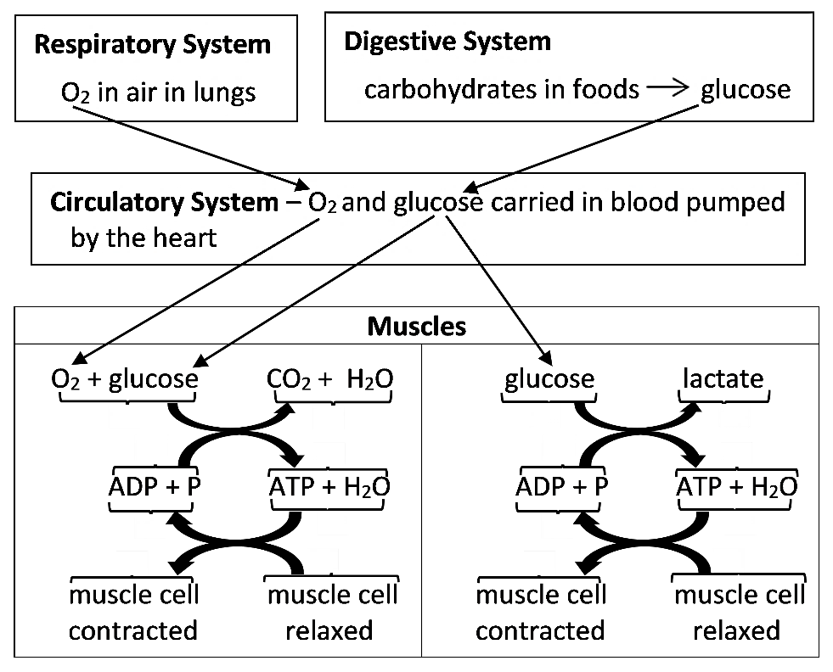
The figure below shows the respiratory and circulatory systems, and how oxygen moves from air in the alveoli of the lungs to blood in the capillaries. Capillaries are tiny blood vessels where oxygen can enter or leave the blood.
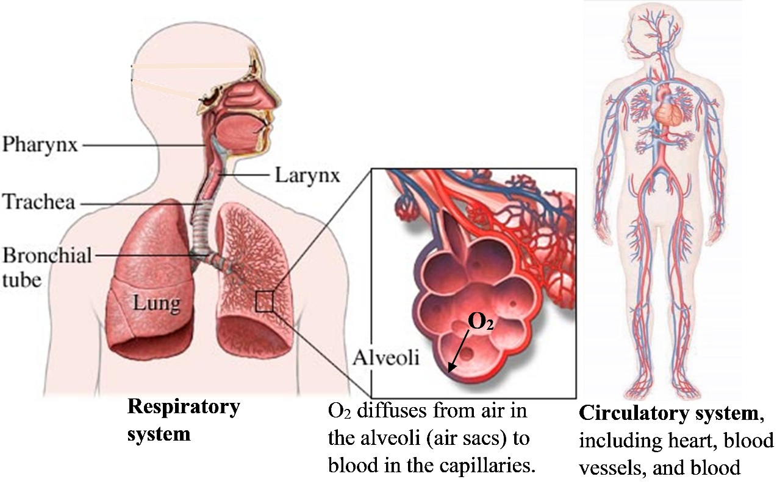

10. Describe how the respiratory system and circulatory system cooperate to supply muscles with oxygen.

How Regular Aerobic Exercise Can Improve Athletic Performance

Aerobic exercise includes running, swimming, and sports that involve a lot of running (e.g. basketball and soccer). Regular aerobic exercise results in multiple changes in a person’s body, including:
- improved heart function, so the heart can pump more blood per second
- more capillaries in the muscles
- more and larger mitochondria in muscle cells.
Each of these effects can contribute to improved athletic performance in long-distance races and sports that involve a lot of running.

11a. Explain how each effect of regular aerobic exercise can increase ATP production in muscle cells and thus improve athletic performance in long-distance races.

Effect of Regular Aerobic Exercise | How this Change Improves Athletic Performance
- Heart can pump more blood per second
- More capillaries in the muscles
- More mitochondria in muscle cells

11b. Complete this table to describe the evidence that supports your explanations of how the effects of regular aerobic exercise improve athletic performance.

Evidence from page 3 concerning the process that produces most of the ATP in muscle cells during long distance races

Evidence from page 1 that supports your explanation of the benefits of A and B (in your answer to question 11a)

Additional evidence from page 4 that supports your explanation of the benefits of A and B

Evidence from page 2 that supports your explanation of the benefits of C

By Dr. Ingrid Waldron, Biology Dept, Univ Pennsylvania, ©2020, but freely available for classroom use. This Student Handout (including a Google Doc version) and Teacher Notes (with instructional suggestions and background information) are available at http://serendipstudio.org/exchange/bioactivities/energyathlete.

